[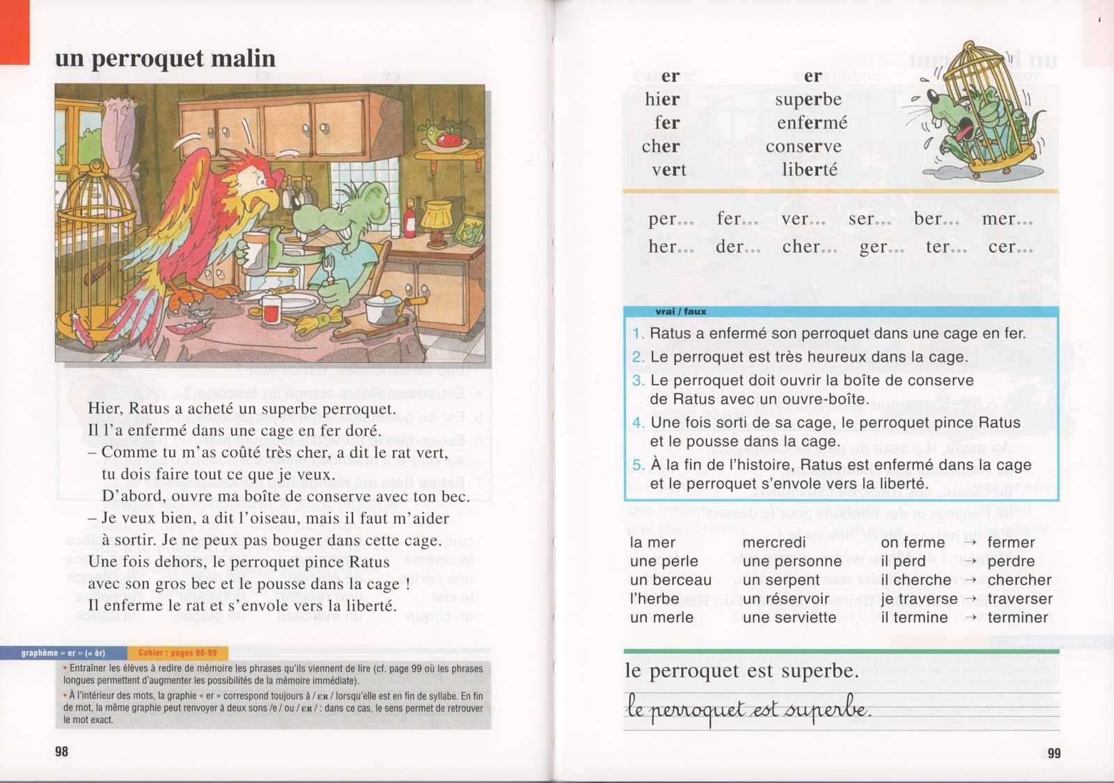](https://3.bp.blogspot.com/-8teiu3b4aOo/V9xA3ekDqVI/AAAAAAAAVdk/jmBPDXfbi9gymGf3jss4a5tEW9GFDqLGwCPcB/s1600/Ratus+et+ses+amis+m%C3%A9thode+lecture+CP_0051.jpg)

[](https://3.bp.blogspot.com/-8teiu3b4aOo/V9xA3ekDqVI/AAAAAAAAVdk/jmBPDXfbi9gymGf3jss4a5tEW9GFDqLGwCPcB/s1600/Ratus+et+ses+amis+m%C3%A9thode+lecture+CP_0051.jpg)